# Typology of shocks + indicators

An event can cause a candidate shock when (1) there is a direct or indirect impact on the socio-ecological system (social capital or environment), (2) it is sudden, and (3) that impact is high. Considering that an event can cause a shock, this one can be classified into one of the five types below based on which subsystem impacts (see below). For instance, the political, economic, and social systems are functionally differentiated subsystems of society (Albert, 2022).

|  |  |  |  |  |  |  |  |  |  |  |  |  |
| --- | --- | --- | --- | --- | --- | --- | --- | --- | --- | --- | --- | --- |
| |  |  | | --- | --- | | **Type of shock** | **Impacted subsystem** | | Ecological | Environment | | Technological | | Economic | Economical | | Societal | Social | | Political | Political | |  |

The environmental shocks are disasters that occur in the environment (Didenko & Kulik, 2018). Some of these disasters are caused by natural conditions and are referred as *natural disasters,* severe weather with potential to pose a significant threat to human health and safety, property, critical infrastructure, and homeland security (Homeland Security, 2024). In this project, we will call **ecological shocks** such natural disasters that fulfills the three criteria mentioned above. Some examples are hurricanes, tornados, floods (Atkinson, 2013). These shocks depend on variables like the changes in the volume of CO2 in the environment; greenhouse gas emissions from industries into the environment; emissions of greenhouse gases from agriculture into the environment; changes in global temperature of the planet; freshwater resource reduction; changes in forested area (Didenko & Kulik, 2018).

Based on the above, we will analyze environmental indicators sourced from databases such as the World Bank, International Monetary Fund, and Our World in Data. From these data sources, we can obtain ecological indicators regarding environmental quality (CO2 emissions, PM2.5 air pollution, precipitation in-depth) and environmental conservation (Forest area, Total natural resources rents, Terrestrial protected areas, Terrestrial and marine protected areas).

On the other hand, human activities also affect the environment; such events are called technological disasters*.* These are commonly studied under environmental contamination (Ritchie & Gill, 2007), meaning a “man-made contamination of an environment that persists over time”(Ritchie & Gill, 2007). Some examples are dam collapses, explosions, and nuclear accidents, which are commonly called *technological catastrophes* (Baum et al., 1983; Manion & Evan, 2002). In this project, we will call **technological shocks** these technological disasters that fulfill the three criteria mentioned above.

Indicators related to this type of shock can be extracted from the *World Bank* database, which provides indicators regarding agricultural productivity (agricultural land, cereal yield, agriculture, value added per worker), energy sustainability (energy intensity level of primary energy, renewable energy consumption, renewable electricity output, access to electricity, access to clean fuels), urban-rural infrastructure (people using at least basic drinking water services, people using at least basic sanitation services), and water security (renewable internal freshwater resources per capita, annual freshwater withdrawals, water productivity, people using safely managed drinking water services).

On the other hand, **economic shocks** are sudden events causing a significant impact on the local economy (economic system), which may not be economic in nature (Besser et al., 2008). For instance, while events like a tornado or the construction of a highway are not considered to be economic in nature, their impact on the economy can be considered shocks.

These economic shocks will be identified through economic capital indicators extracted from the World Bank Group measuring economic activity, and Organization for Economic Co-operation and Development (OECD) Main Economic Indicators (MEI). For instance, GDP growth or contraction, unemployment rate, inflation, and government decisions on budget and public debt.

Following a similar principle, political shocks have been defined as “dramatic change in the international system or its subsystems that fundamentally alters the processes, relationships, and expectations that drive nation-state interaction” (Goertz & Diehl, 1995), or as a “sudden, violent change in a host country’s political or institutional contexts” (Darendeli et al., 2021). In this project, a **political shock** will be any event that causes dramatic changes in the political system of a country. Territorial changes, alterations in international power distribution, civil wars, and national independence are examples of this.

The identification of political shocks will be aided by indicators that measure safety and security, social polarization, trust in institutions, and quality of life. Some of these are closely related to societal factors, so the assignment to either political, social shock, or both will depend on what each individual metric measures. These indicators will be obtained from the United Nations Development Programme (UNDP), OECD, World Bank, and The Social Progress Imperative. Examples are the Global Residence Index, Global Peace Index, political polarization, Worldwide Governance Indicators (WGI), and Social Progress Indexes.

**Societal shocks** are events that impact the societal system, affecting the capacity of societies to maintain their core social functions, mainly through effects on society’s health, and increased social inequalities (Wernli et al., 2021). Examples of societal shocks affecting societies’ health are disease epidemics (Cook et al., 2019), famines (Vågerö et al., 2013), and genocide (Keinan-Boker, 2014). Other events like armed conflicts create spatial inequalities through structural destruction (e.g. demolition of agricultural land, hospitals, markets, roads, schools, etc.), and events of massive international migration also hold the potential for value/normative transformations in society (Portes, 2010). Considering that social changes might be gradual, these events will only be considered societal shocks if their impact is sudden and elevated, as stated in the three criteria for shock identification.

Several data sources, including the World Bank, the World Happiness Report, the United Nations Development Programme, Our World in Data, Freedom House, and IDMC, provide indicators concerning societal shocks. These sources encompass indicators reflecting household, business, and citizen perceptions of governance quality. Additionally, indicators such as the Happiness Index, the Human Development Index, the Healthcare Access and Quality Index, Freedom Rates, and internal displacements are also considered.

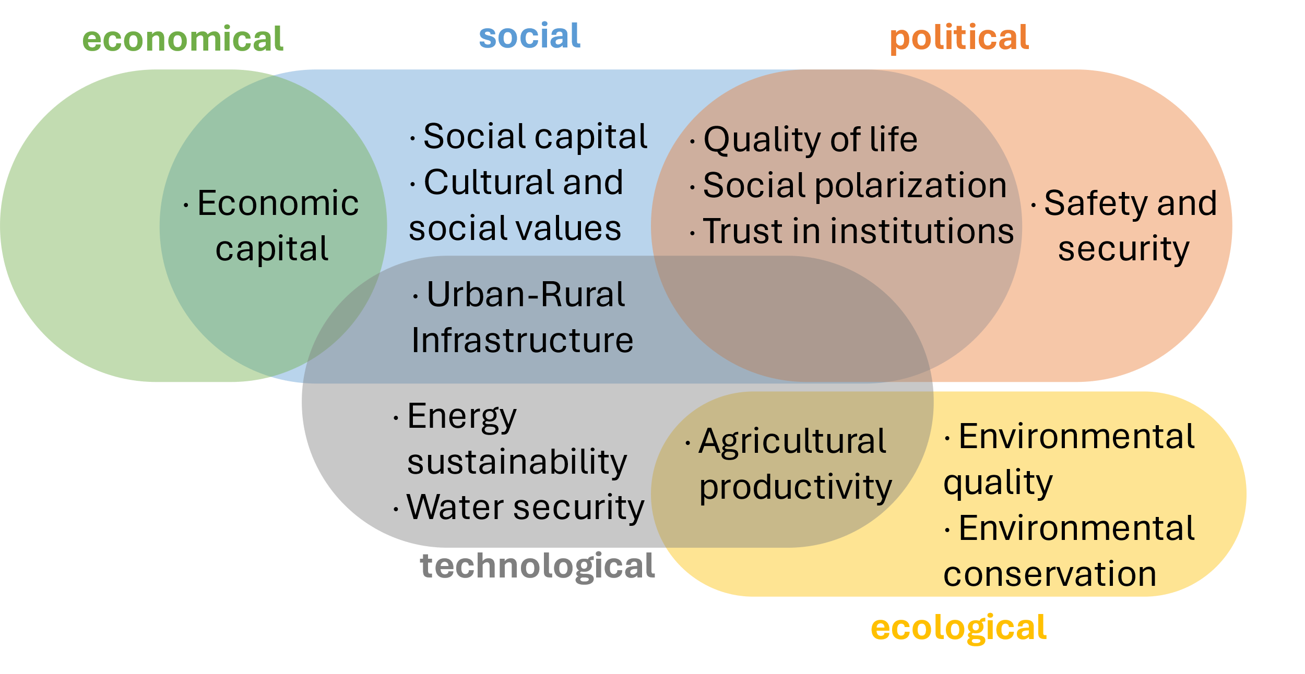

Figure 1. Types of shock and potential variables from public data sources to identify them.

REFERENCES

Albert, M. (2022). Observing world politics: Luhmann's systems theory of society and international relations. In *Luhmann and Law* (pp. 525-552). Routledge.

Atkinson, C. L. (2013). Toward Resilient Communities. <https://doi.org/10.4324/9780203076309>

Baum, A., Fleming, R., & Davidson, L. M. (1983). Natural disaster and technological catastrophe. *Environment and Behavior*, *15*(3), 333-354.

Besser, T. L., Recker, N., & Agnitsch, K. (2008). The impact of economic shocks on quality of life and social capital in small towns. *Rural Sociology*, *73*(4), 580-604.

Cook, C. J., Fletcher, J. M., & Forgues, A. (2019). Multigenerational Effects of Early-Life Health Shocks. *Demography*, *56*(5), 1855-1874. <https://doi.org/10.1007/s13524-019-00804-3>

Darendeli, I., Hill, T., Rajwani, T., & Cheng, Y. (2021). Surviving the Arab Spring: socially beneficial product portfolios and resilience to political shock. *Multinational Business Review*, *29*(4), 522-544.

Didenko, N., & Kulik, S. (2018). Environmental shocks: modelling the dynamics. IOP conference series: earth and environmental science,

Goertz, G., & Diehl, P. F. (1995). The initiation and termination of enduring rivalries: The impact of political shocks. *American Journal of Political Science*, 30-52.

Homeland Security. (2024). Natural Disasters. In

Keinan-Boker, L. (2014). “The mothers have eaten unripe grapes and the children's teeth are set on edge”: the potential inter-generational effects of the Holocaust on chronic morbidity in Holocaust survivors’ offspring. *Israel Journal of Health Policy Research*, *3*(1), 11. <https://doi.org/10.1186/2045-4015-3-11>

Manion, M., & Evan, W. M. (2002). Technological catastrophes: their causes and prevention. *Technology in Society*, *24*(3), 207-224.

Portes, A. (2010). Migration and Social Change: Some Conceptual Reflections. *Journal of Ethnic and Migration Studies*, *36*(10), 1537-1563. <https://doi.org/10.1080/1369183x.2010.489370>

Ritchie, L. A., & Gill, D. A. (2007). Social capital theory as an integrating theoretical framework in technological disaster research. *Sociological Spectrum*, *27*(1), 103-129.

Vågerö, D., Koupil, I., Parfenova, N., & Sparen, P. (2013). Long term health consequences following the Siege of Leningrad. *Early life nutrition and adult health and development*, *207*, 225.

Wernli, D., Clausin, M., Antulov-Fantulin, N., Berezowski, J., Biller-Andorno, N., Blanchet, K., Böttcher, L., Burton-Jeangros, C., Escher, G., & Flahault, A. (2021). Building a multisystemic understanding of societal resilience to the COVID-19 pandemic. *BMJ global health*, *6*(7), e006794.

Olteanu, A., Castillo, C., Diaz, F., & Vieweg, S. (2014). CrisisLex: A Lexicon for Collecting and Filtering Microblogged Communications in Crises. *Proceedings of the International AAAI Conference on Web and Social Media*, *8*(1), 376-385. <https://doi.org/10.1609/icwsm.v8i1.14538>

Jenkins, C. J., Taylor, C. L., Abbott, M., Maher, T. V., & Peterson, L. (2012). The World Handbook of political indicators IV: An introduction and codebook. *Mershon Center for International Security Studies, The Ohio State University*.

Wolfson, M. H., & Epstein, G. A. (2013). *The handbook of the political economy of financial crises*. OUP USA.